

## Walchand College Of Engineering, Sangli.

#### (An Autonomous Institute)

**Department**

**Of**

#### Computer Science and Engineering

TY CSE Mini Project-2

Report

On

**Detecting Number Plate of Moving Vehicle**

Submitted by

**Sanket Jadhav (2020BTECS00005)**

**Somesh Sharma (2020BTECS00008)**

**Rushikesh Ware (2020BTECS00012)**

Under the Guidance of

##### Dr. B. F. Momin

Guide

Computer Science & Engg. Dept, WCE, Sangli.

**2022-2023**



Walchand College of Engineering, Sangli

(An Autonomous Institute)

**Department**

**Of**

**Computer Science and Engineering**

### CERTIFICATE

This is to certify that the Project Report entitled, **“DETECTING NUMBER PLATE OF MOVING VEHICLE”** submitted by Mr. Sanket Jadhav, Mr. Somesh Sharma, Mr. Rushikesh Ware, to Walchand College of Engineering ,Sangli, India, is a record of bonafide Project work of course *“5CS346” “Mini Project-2”* carried out by him under my/our supervision and guidance and is worthy of consideration for the award of the degree of Bachelor of Technology in Computer Science & Engineering of the Institute.

|  |  |  |
| --- | --- | --- |
| **Dr. B. F. Momin** |  | **Dr. M. A. Shah** |
| Guide |  | Head Of Department |
| Computer Sci. & Engg. Dept, |  | Computer Sci. & Engg.Dept, |
| WCE, Sangli. |  | WCE, Sangli |

# Acknowledgement

We would like to express our special thanks of gratitude to our project guide Dr. B. F. Momin Sir and our HOD Dr. M. A. Shah Mam who gave us the golden opportunity to do project on “Detecting Number Plate of Moving Vehicle”. It helped us in doing a lot of research and we came to know about a lot of new things related to this topic.

At last but not the least, we would like to thank everyone who helped and motivated us to work on this project.

# Declaration

I hereby declare that work presented in this project report titled **” DETECTING NUMBER PLATE OF MOVING VEHICLE”** submitted by me in the partial fulfillment of the requirement of the award of the degree of **Bachelor of Technology (B.Tech)** Submitted in the **Department of Computer Science & Engineering, Walchand College of Engineering, Sangli**, is an authentic record of my project work carried out under the guidance of Dr. B. F. Momin.

(Signature)

Date: 05-12-2022

Place: Sangli

Sanket Jadhav 2020BTECS00005

Somesh Sharma 2020BTECS00008

Rushikesh Ware 2020BTECS00012

## Table Of Contents

1. Project title 5
2. Abstract 6
3. Introduction and Related work 7
4. Problem statement 7
5. Objectives 7
6. Methodology 8
7. Project Diagrams (UML diagrams, Flow chart etc.) 10
8. Testing (Unit, System, Integration etc.) 11
9. Results and Conclusion 12
10. References 13

###### List Of Figures:

* Figure 1. Object Detection
* Figure 2. Detected Number Plate
* Figure 3. Flowchart
* Figure 4. Input Image
* Figure 5. Output Image
* Figure 6. Working System

#### Project title

Detecting Number Plate of Moving Vehicle

#### Abstract

Number plate recognition is an image processing technology which uses number plate to identify the vehicle. The goal of this project is to develop an algorithm that could detect number plate from image or video. This information can be used for various applications like parking management. It first captures the picture of moving vehicle and then extracts the number from its registration plate.

#### Introduction and Related work

This Project aims to detect number plate from image or video. This could be helpful in Security, Surveillance and Parking Management. We have developed an algorithm that can detect number of vehicle.

#### Problem statement

Detecting Number Plate of Moving Vehicle

#### Objectives

1. Study of EasyOCR, Yolo for image processing.
2. Design an algorithm which can extract a registration number from image of a vehicle having number plate.
3. Dashboard for vehicle entry and exit.
4. Analysis about Accuracy of different algorithms for detecting number plate of vehicle.

#### Methodology

Given an input video or image firstly, the frame(s) are captured using OpenCV library of Python. OpenCV is used for Computer Vision i.e. understanding images and videos and extracting information from them. It contains various function which can be used for image processing. To improve accuracy, every frame can be individually analyzed. Processing frames one by one is time consuming, but it could be improved using CUDA-compatible (Compute Unified Device Architecture) NVIDIA GPU.

The Frames captured are passed to YOLO v5 model. YOLO an acronym for 'You Only Look Once', is an object detection algorithm that divides images into a grid system. Each cell in the grid is responsible for detecting objects within itself. YOLO is one of the most famous object detection algorithms due to its speed and accuracy. Bounding box is given scores based on the class that might be associated. Here there is only one class called Number plates. Yolo methodology of matrix-based approach of dividing the image into regions and finding Region of Interest (ROI). Different possibilities of ROI are marked by Yolo without any filters.

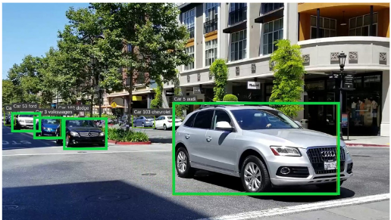

Figure 1. Object Detection

This object detected by YOLO v5 is then processed for vehicle detection. If vehicle is detected then it is further passed for number plate detection. In general, License Plate is in form of a rectangular shape. Thus, algorithm looks for geometrical shapes of a rectangular proportion. (In India, most license plates are white or yellow, and therefore we can also use color analysis.) Then it finds and connects to the relevant rectangular corners. Finally, the areas connected to the box are connected and all rectangular areas of interest are extracted. Hence, the number plate is cropped. The cropped number plate is converted into grayscale image for further processing. Applying OCR to grayscale image is much faster than colored image.

From this detected number plate, number is extracted using EasyOCR library. EasyOCR is a popular library used for OCR i.e. Optical Character Recognition. EasyOCR is actually a python package that holds PyTorch as a backend handler. PyTorch is an open-source library used in machine learning library developed using Torch library for python program. Programmer can build a complex neural network with ease using PyTorch as it has a core data structure, Tensor, multi-dimensional array like Numpy arrays.

EasyOCR like any other OCR(tesseract of Google or any other) detects the text from images also when high-end deep learning library(PyTorch) is supporting it in the backend which makes it accuracy more credible. EasyOCR supports 80+ languages for detection purposes. Here, we are using the Reader class from easyocr class and then passing [‘en’] as an attribute which means that now it will only detect the English part of the image as text, if it will find other languages then it will ignore those text.

Now, as in the above line, we have set the attribute for language so, here we are loading the IMAGE_PATH in the readText() function. We get the result in the form of a 2-D NumPy array. Further the detected number plate is displayed and saved.

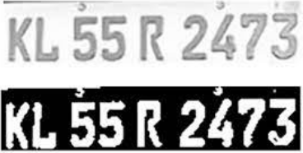

Figure 2. Detected Number Plate

#### Project diagrams

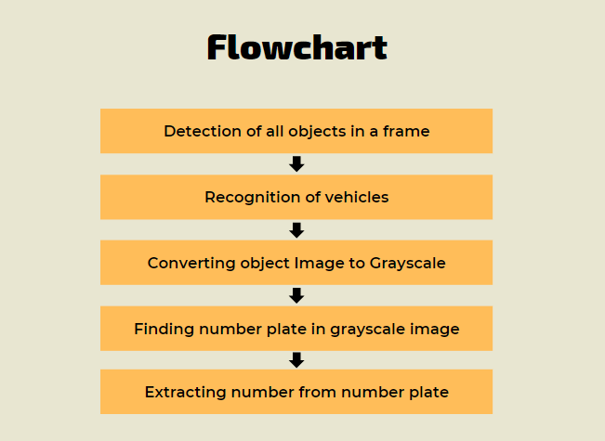

Figure 3. Flowchart

#### Testing (Unit, Integration and System)

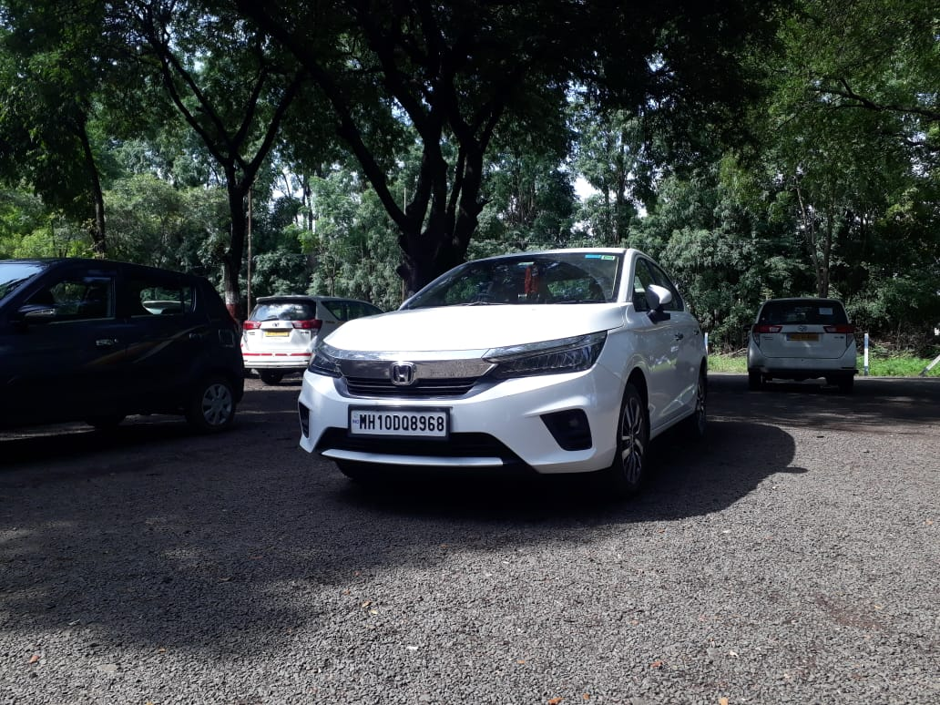

Figure 4. Input Image

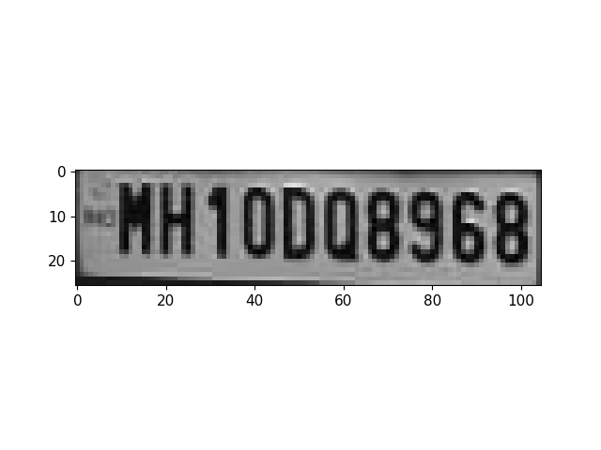

Figure 5. Output Image

#### Results and Conclusion

Algorithm is able to detect number plate from the given image or video. Initially, the camera will be used to capture the image. Once the image is captured, the algorithm will process it by converting it into grayscale, followed by extracting the possible number plates and finally recognizing the registration number of the vehicle.

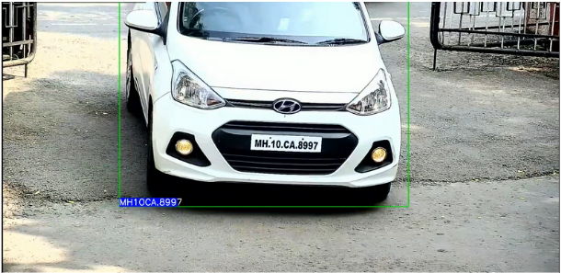

Figure 6. Working System

YOLOv5 is very effective for vehicle number plate recognition using machine learning. From the above results, we can conclude that number plate recognition will perform better as the quality of the camera used for scanning the plate will be excellent. Using low quality camera will degrade the performance and may misclassify the characters.

#### References

[1] Prasad Molawade, Shruti Shanbhag et. al., “Number Plate Recognition using Machine Learning”, Volume 1 Issue 1.

[2] Tella Pavani, DVR Mohan, “Number Plate Recognition by using open CV- Python”, International Research Journal of Engineering and Technology (IRJET) e-ISSN: 2395-0056 Volume: 06 Issue: 03.

[3] Shashidhar R, Roopa M et. al., “Vehicle Number Plate Detection and Recognition using YOLO-V3 and OCR”, 2021.

[4] G. Hsu, A. Ambikapathi, S. Chung and C. Su, "Robust license plate Car License Plates Recognition Using Neural Network detection in the wild," 2017 14th IEEE International Conference on Technologies," 2019 International Conference "Quality Advanced Video and Signal Based Surveillance (AVSS), 2017, pp. Management, Transport and Information Security, Information.

[5] L. Xie, T. Ahmad, L. Jin, Y. Liu and S. Zhang, "A New CNN-Based and Shashidhar R “Detection of Non-Helmet Riders and Extraction Method for Multi-Directional Car License Plate Detection," in IEEE of License Plate Number using Yolo v2 and OCR Method” Transactions on Intelligent Transportation Systems, vol. 19, no. 2, International journal of Innovative Technology and Exploring.